LANDING PAGE AUDIT REPORT
Top MBA Colleges in Ahmedabad → Audit → Improved Version

Prepared By: Ayushi Prajapati
Digital Marketer
Date: [26/09/2026]


Table of Contents
This report is auto-generated template. Update fields after filling.
1. Executive Summary ........................................................................ 2
2. Project Overview & Goals ............................................................... 2
3. Element-wise Audit (Headline, Offer, CTA, Social Proof) ................... 3
4. Before vs After - Wireframe & Copy ............................................. 4
5. Expected Uplift & Impact .............................................................. 5
6. Recommendations & Next Steps .................................................. 5

1. Executive Summary
This document presents a comprehensive audit of the existing “Top MBA Colleges in Ahmedabad” landing page for Indus University. The audit evaluates 5 key conversion pillars: Messaging, Offer, Call-to-Action (CTA), Social Proof, and User Journey. The goal is to identify friction points that may be reducing enquiry and admission conversion rates and to propose a redesigned version that can improve user engagement, lead generation, and overall conversion performance.

2. Project Overview & Goals
Brand Name : Top MBA Colleges in Ahmedabad
Landing Page URL: https://indusuni.ac.in/mba-colleges-in-ahmedabad.php
Audit Date: [26/09/2026]
Primary Goal: Lead Generation
Current Conversion Rate: [No Details Found]
Target Conversion Rate: [No Details Found]
Traffic Source: [Meta Ads / Google Ads / Organic]

3. Element-wise Audit
Detailed analysis of each critical landing page element. Replace placeholder text with your actual findings.
Element | Current Issue | Impact (High/Med/Low) | Recommended Fix
Headline | The Headline is too long | Medium | Low clarity and improved headline properly
Sub-Headline / Offer | Sub - Headline is not a bed but its look like article | Medium - User not motivated to act | Text-heavy, visual proof missing
Call-to-Action (CTA) | Multiple CTAs without clear hierarchy | High - No clear next step | Instead of changing between Apply Now, Enquire Now, Enrol With Us, etc.
Social Proof | The Placement Proof is clearly visible | High trust | No needed
Form / User Journey | Unnecessary questions can lead to a lower-quality user experience. | High - form friction | Reduce to 3–4 essential fields = Name → Phone → Email that is enough
Visuals & Copy | long paragraphs | Medium - Low engagement | Current long SEO-style headline ki jagah concise student-focused headline:Build Your MBA Career at Indus University, Ahmedabad

4.1 BEFORE - Current Version
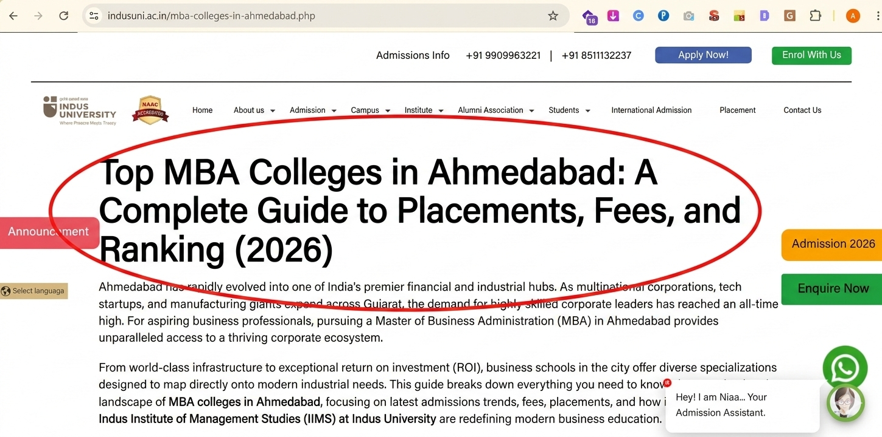
Issues :
- The Headline is too long.
This page looks like an article page, It doesn’t look like an admission landing page.
The headline can be tailored to match the student’s intent: “Build Your MBA Career at Indus University, Ahmedabad”
Observations:
• Above the fold: Logo + Generic headline
• No clear offer
• CTA at bottom - 'Submit'
• No social proof
• Form with 8 fields

4.2 AFTER - Improved Version (Your Redesign)

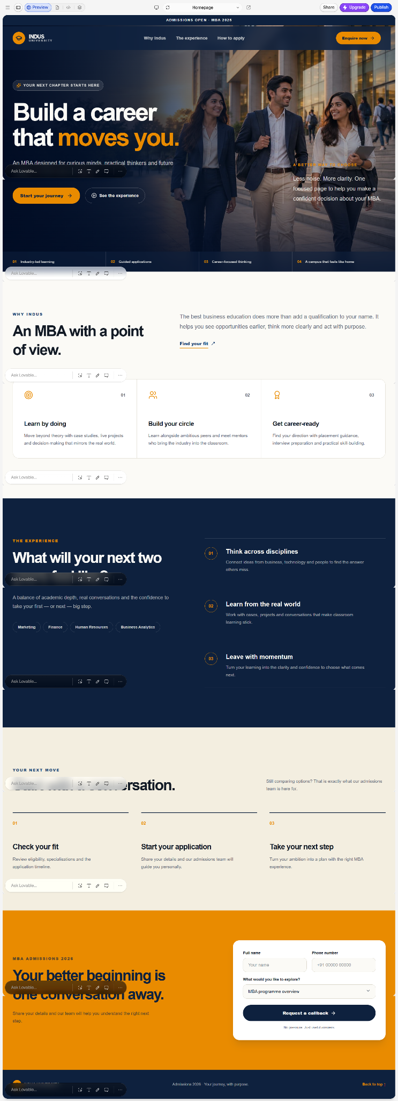

5. Expected Uplift & Impact
Metric | Before (Current) | After (Expected - Your Estimate)
Bounce Rate | Not founded | Not founded
Form Conversion Rate | Not founded | Not founded
Time on Page | Not founded | Not founded
Lead Quality Score | Not founded | Not founded
Overall Conversion Uplift | Not founded | Not founded

6. Recommendations & Next Steps
1. Implement A/B Test: Apply the recommended changes to messaging, CTAs, social proof, form length, and visual hierarchy.
2. Track: Measure CTA clicks, form starts, form submissions, and enquiry conversion rate through GA4.
3. Iterate: Optimize the page based on actual user behaviour and test results.
4. Learnings:Record successful changes and insights for future landing pages.
Tools Used: Google Docs, Full Page Screenshot, Chrome DevTools
Outcome: [Add your final result if you tested - e.g., 'Achieved 2.8x uplift in test']

